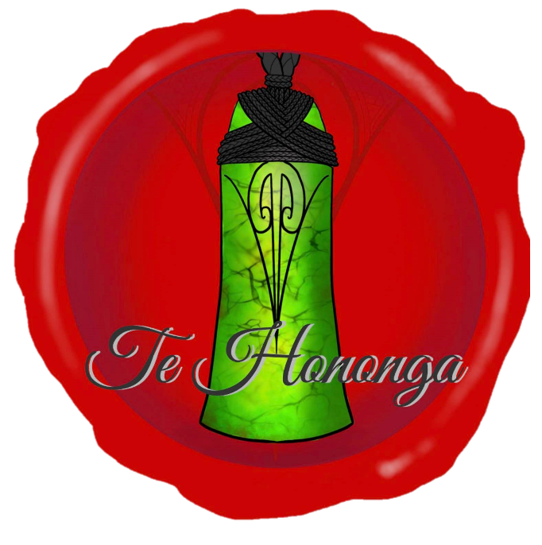

wānanga 1

prework

whanaungatanga
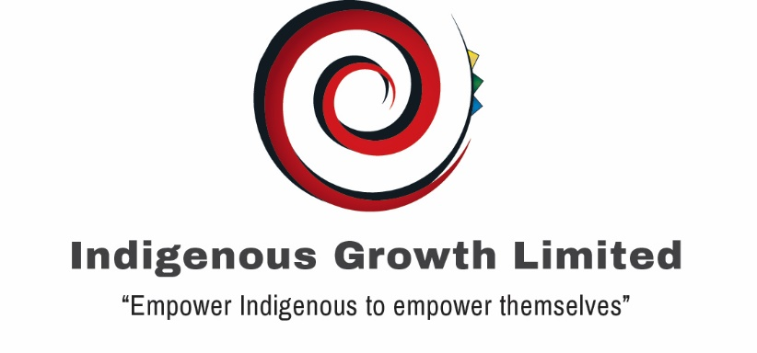

WELCOME
Nau mai, haere mai.
Welcome to the New Zealand Post Māori leadership programme Te Hononga.
Throughout each wānanga we will be using universal indigenous values to show how these can enhance your personal (home) and professional (work) life.
Wānanga 1 – Mana Wairua
We will explore core principles of personal leadership using essential elements of indigenous traditions and values. You may recognise these through your own upbringing or connections with your whānau and communities.
Our first wānanga is a compulsory noho marae (learning wānanga and sleep over) where you will have the opportunity to immerse yourself in the learning environment and interact in a safe and supportive place. This first wānanga will explore:
- Learning styles and how you experience learning - helping you understand the best way for you to get the most out of our learning sessions;
- Whanaungatanga – introduction to these traditions and values that will be used throughout the programme. These core principles will link to models that you can use to support your achievement of goals in work and at home;
- Mana Wairua – defining what your Wairua represents and understanding how that provides motivation, guidance for decision-making and helps you prioritise goals in life; and
- Rōpū Projects – exploring options to create connection and support the Māori staff across the business.
The agenda for Wānanga 1 is as follows:
Rā 1: Whakawhanaungatanga
8.30am | Pōwhiri – Mataatua Marae, 17 Killington Cres, Mangere, AKL
 | Whanaungatanga
 | Learning Approach
 | IGL Model
 | Rōpū Projects
 | Rā 1 Wrap Up
Rā 2: Mana Wairua
8.00am | Rā 2 Opening
 | Indigenous Coaching
 | Mana Wairua
 | Rā 2 Wrap Up

In this document, we aim to set the foundations for our first wānanga. You will explore who you are and what is important to you. You will then answer questions to start to create your own wairua statement and develop ideas around the rōpū projects all of which will be very helpful for you throughout our programme.
To prepare for the wānanga we ask you to complete a few short reflections. The purpose of these reflections is to:
- Ensure that you have content ready for some of our working sessions and to be prepared for the subjects at hand.
- Allow you to capture any questions that you may have on the subjects to be covered by the wānanga.
We expect that this preparation will take 60-90 minutes to complete.
We look forward to working with you in the coming session.

Michael Moka
Michael Moka
Lead Facilitator
Indigenous Growth Limited

EXPECTATIONS FOR WĀNANGA 1
Based on what you understand about Te Hononga from the orientation session:
This section is for you to consider what you hope to gain from the first wānanga. We also ask you to consider how you will contribute to the learning of the group.
What do you hope to gain from the first Te Hononga wānanga?
What contribution can you make to the wānanga and learning sessions?

WHAKAWHANAUNGATANGA
In Te Hononga you will be asked to introduce yourself using your pepeha. This page allows you to make notes to help you complete this important activity. We appreciate that for many of you this information may be new for you to gather. Fill in what you can. Here are some tips to help you:
- If you do not know it yourself, contact family members who may know
(parents, siblings, grandparents, cousins etc). Your children may know also.
- Use Google or Facebook to add to what you know.
- If you are confused on whose pepeha to use, we are more than happy for you to use either parent. Traditionally it will be your father’s side. However, we recommend using the side where you have a stronger relationship.
- Make sure they all connect to each other i.e. if you use your father’s side, stick with it.
- Fill in what you can and what is relevant i.e. if you don’t have a waka you do not need to put a waka in.
Ko ______________________________________ te Maunga (Mountain)
Ko ______________________________________ te Moana (Harbour)
Ko ______________________________________ te Awa (River)
Ko ______________________________________ te Waka (Canoe)
Ko ______________________________________ te Iwi/ Nationality (Collective)
Ko ______________________________________ te Hapū/Village (Group)
Ko ______________________________________ te Marae/Church (Meeting Place)
Ko ______________________________________ te Whānau (Family names)
Ko ______________________________________ tōku Ingoa (Name)

MANA WAIRUA
This part of the pre-work is to get you thinking about your Wairua Statement (personal purpose). Knowing your Wairua statement will be an important source of motivation and it offers a benchmark to guide the many choices we face in life. We ask you to spend a bit of time working through the subject of purpose as well as getting you to begin to think further about your own purpose.
What does purpose mean to you? How do you use it in your life today, if at all?
Thinking about people you admire; what do you notice about how they live their life?
Why do you think purpose is important for leadership?

LIFE CELEBRATION EXERCISE
This exercise is designed to help you think further about what is most important to you.
IMPORTANT: PLEASE COMPLETE BEFORE WORKSHOP AND READ INSTRUCTIONS AND QUESTIONS CAREFULLY.
When looking at what is important in your life, you need to create a sense of perspective. This Life Celebration exercise does this by getting you to imagine a future you, and that you have lived a full, long life that you are looking back over. This longer-term perspective helps you to put aside day-to-day issues and highlights those things that are most important to you.
It is important to realise that the focus of this exercise is imagining the quality of the life you lived, the person you have become, the things you have achieved, and the positive ways in which you have influenced others. Assume that you have been successful in your self-development. What does this look like?
To work well, this exercise requires more than “top of the head” responses. The more vividly you imagine the situation and the level of detail in the notes you make, will determine the value you get from the exercise.
Take your time so that it can work for you. Set aside a time and place where you won’t be interrupted. Take this booklet and a pen with you and work thorough the following reflection questions.
Imagine it is the future, you have lived the largest part of your life and you are looking back on your life.
Who is there that is important to you?

What do you notice about the mix of people in the group that has gathered to celebrate your life?
What is significant about the location that has been chosen for this important event?

Imagine that you are now listening to what people are saying about you, both in formal speeches, along with the informal conversations that are happening across the groups present. Imagine what you would like people to say.
What personal assets (skills, talents, attitudes, values) do they admire most in you?

What differences do they say you have made to their lives?
How have you been a role model for others?

What do they say are the things you have felt passionate about?
How did you live your life to make sure you had time for these important areas of your life?
What has been “not negotiable” in your life - those values/issues that you would not compromise on?
What did you do that allowed you to stay strong with these aspects of your life?

What particularly pleases you about what they say about you?
What might this mean for how you are living your life today?

What are 4 main roles you play in your life? How do you describe the roles that you play now and how you would like them to be? I am….. and I’d like to be
Roles | Descriptors
Example: I am an Uncle to my nieces and nephews | I am: an example, fun  I’d like to be: fun, role model, giving, loving, reliable, honest
1. | I am:  I’d like to be:
2. | I am:  I’d like to be:
3. | I am:  I’d like to be:
4. | I am:  I’d like to be:
5. | I am:  I’d like to be:

RŌPŪ PROJECT
The final section of your prework relates to the rōpū (group) project.
As the first group to start Te Hononga within New Zealand Post we envisage this rōpū as being important to help develop a strong, inclusive culture that supports the contribution that Māori can make within the business.
What ideas do you have about how Māori leaders can be more connected within New Zealand Post?
What would you see as being the benefits of these connections?
What role could you play in helping these ideas come to life?

OTHER NOTES

